

ISSS602: Data Analytics Lab

Assignment 2: Hospitality Segmentation with Cluster Analysis

12 September 2025

NOR HENDRA BIN ABDUL RAHMAN
STUDENT ID: 01505038

Estimated word count for content (not counting captions, references, content page, etc): ~3600

Table of Contents
1. Objective 1
2. Data Pre-Checks 1
2.1. Basic Checks 1
2.2. Hygiene & Normalization 2
2.3. Keys & Geo Basics 3
2.4. Metadata Level Conformance 4
2.5. Variables Quick Look (Summary) 5
3. Data Preparation 7
3.1. Defusing Dummy Data: Height 7
3.2. Exposure Gap (Collinearity between 2 Variables) 8
3.3. Log Transformation 9
3.4. Z-Scoring 10
3.5. Final Missingness Check 11
3.6. Duplicate rows 11
3.7. Clustering Variables 12
3.8. Complete Cases 13
4. Data Analyses 14
4.1. Univariate Exploration of Clustering Drivers - Histograms 14
4.2. Univariate Exploration of Clustering Drivers – Box Plots 15
4.3. Tying in Univariate Analyses 16
4.4. Bivariate Analysis 17
4.5. Hierarchical Clustering: Cluster Observation 18
4.6. Hierarchical Clustering: Dendrogram 19
4.7. K-Means Clustering 22
4.8. Gaussian Mixture Model 24
4.9. Price by Segment: What Each Cluster Commands 28
4.10. What Drives Price: Product Type & Access Features 29
5. Summary of Results 30
6. Managerial Recommendations 30
7. References 32

Figure 1: Code snippet of basic checks (Assign2/1_DataChecks/1_DataPreChecks.sas) 1
Figure 2. Result of Basic Checks 1
Figure 3. Code snippet for Hygiene & Normalization(Assign2/1_DataChecks/2_HygieneNormalization) 2
Figure 4. Results for Hygiene and Normalization Checks 2
Figure 5. Code snippet of keys & geo basics. (Assign2/1_DataChecks/3_KeysGeoBasics.sas) 3
Figure 6. Result from the Key & Geo Checks 3
Figure 7. Code snippet of Metadata's Conformance Checks(Assign2/1_DataChecks/4_MetadataConformance.sas) 4
Figure 8. Results of the metadata conformance checks and code to check for unmapped type. 4
Figure 9. Code snippet to change categorical variables to numeric measures. (Assign2/1_DataChecks/5_VisualizationPreChecks) 5
Figure 10. Histogram of variables (Assign2/Reports/1_QuickLook) 5
Figure 11. Box Plots of Variables(Assign2/Reports/1_QuickLook) 6
Figure 12. Correlation Matrix between Variables, results arrange in descending correlation (Assign2/Reports/1_QuickLook) 6
Figure 13. Code snippet of replacing -1 in height and its results(Assign2/2_DataPreparation/1_HeightFix) 7
Figure 14. Scatter plot of grond_z vs slr_median_rcp45_2030 8
Figure 15. Code snippet of grond_z and slr_median_rcp45_2030 and its checks. (Assign2/2_DataPreparation/2_ExposureGap.sas) 8
Figure 16. Result of checks 8
Figure 17. Code snippet of log transformation for Rooms, Area, and Price (Assign2/2_DataPreparation/3_LogTransformation.sas) 9
Figure 18. Result of log transformation 9
Figure 19. Histogram and box plot of log-transformed variables 10
Figure 20. Code snippet and results of Z-scoring variables(Assign2/2_DataPreparation/4_ZScoring.sas) 10
Figure 21. Code snippet of final missingness check and its results (Assign2/2_DataPreparation/5_MissingCheck.sas) 11
Figure 22. Duplicate check results and code snippets (Assign2/2_DataPreparation/6B_DuplicateChecks.sas) 11
Figure 23. Sample duplicate rows where all the values are the same. 12
Figure 24. Duplicates removed sanity check (Assign2/2_DataPreparation/6B_RemovingDuplicates) 12
Figure 25. Code snippet for complete cases and its results (Assign2/2_DataPreparation/7_CompleteCases.sas) 13
Figure 26. Result of checking shape on Complete Cases(Assign2/2_DataPreparation/8_CCCheck.sas) 13
Figure 27. Histograms of Clustering Drivers 14
Figure 28. Box plots of clustering drivers 15
Figure 29. Code snippet for shape, symmetry and salience of univariate analyses 16
Figure 30. Result of findings to tie-in with Univariate Analyses 16
Figure 31. Correlation Matrix of Clustering Drivers 17
Figure 32. Correlation values between clustering drivers 17
Figure 33. Cubic Clustering Criterion with the 6 Clustering Variables 18
Figure 34. Results of Cluster Observations(Assign2/3_ExploreVisualize/1_HierarchicalClustering.ctk) 18
Figure 35. Code chunk to bin coordinates into quantiles for dendrogram (Assign2/3_ExploreVisualize/2A_Dendrogram.sas) 19
Figure 36. Result of the binning of latitude and longitude. 20
Figure 37. Label and Proximity Tag of Dendrogram 20
Figure 38. Dendrogram of the binned latitude and longitude vs the 6 cluster variables 21
Figure 39. Result from the Cluster Observation Task 21
Figure 40. Aligned Box Criterion for K-Means Clustering 22
Figure 41. Parallel coordinates of K-means clustering. 22
Figure 42. K-means clustering of the 6 clustering variables 23
Figure 43. Output of GMM (Assign2/3_ExploreVisualize/3_GMM.sas) 25
Figure 44. GMM Cluster Scatter Plot of Price (Log Transformed and Z-scored) vs Distance to Sea (Z-scored) 26
Figure 45. GMM Cluster Profiles 27
Figure 46. GMM Cluster (Means across standardized drivers) 27
Figure 47. Cluster ID vs Average Prices 28
Figure 48. Average Price by Access Features 29

Objective
The objective of this report is to segment Northern Adriatic coastal accommodations into defensible clusters using rigorously prepared data and SAS Viya analyses (EDA, variable reduction, and multiple clustering methods), and translate the results into concise, evidence-based profiles and recommendations.

Data Pre-Checks

Basic Checks
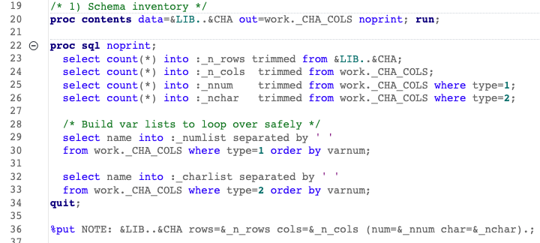

Figure 1: Code snippet of basic checks (Assign2/1_DataChecks/1_DataPreChecks.sas)
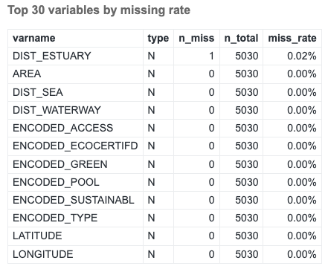
Figure 2. Result of Basic Checks
The initial audit isn’t accurate because it only counted true SAS missings (numeric . and blank character values). It did not treat common placeholder tokens ("NA", "N/A", "NULL", ".", "-", "UNKNOWN") as missing, nor numeric sentinels (e.g., -1) that mean “unknown.” As a result, the “only one missing in DIST_ESTUARY and 0% elsewhere” finding understates real missingness and gives a false sense of completeness.

Hygiene & Normalization
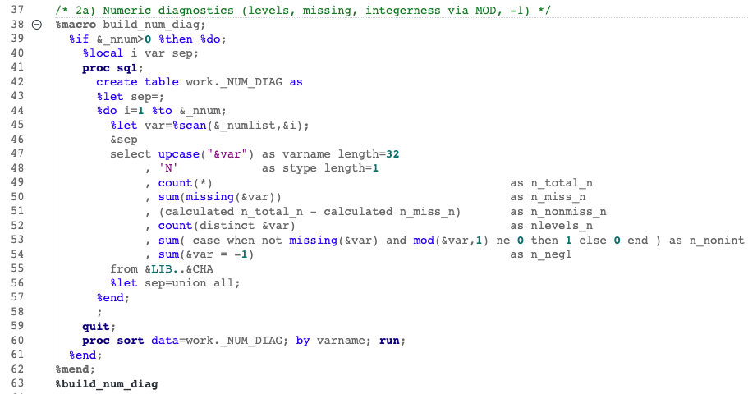
Figure 3. Code snippet for Hygiene & Normalization(Assign2/1_DataChecks/2_HygieneNormalization)
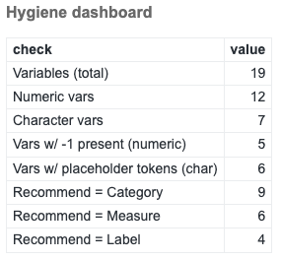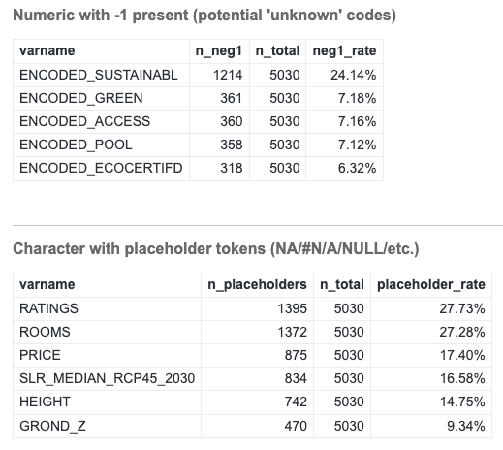
Figure 4. Results for Hygiene and Normalization Checks
The six geospatial/area distances behave as clean continuous measures. Practically, the encoded_* variables should be treated as categorical (with an “Unknown” level for −1), normalize placeholders to missing, parse character-numerics to real numbers, and then proceed with necessary steps for it to be data-ready for clustering analysis.

Keys & Geo Basics
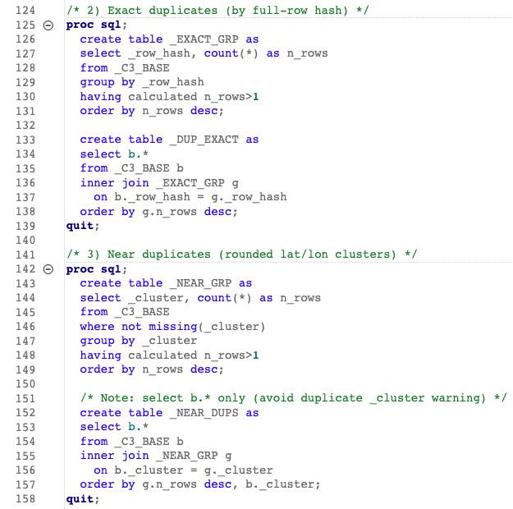
Figure 5. Code snippet of keys & geo basics. (Assign2/1_DataChecks/3_KeysGeoBasics.sas)
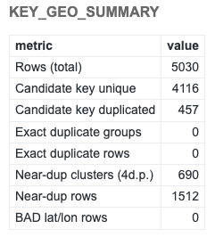
Figure 6. Result from the Key & Geo Checks

The key and geospatial checks indicate generally clean coordinates but meaningful duplication pressure. Out of 5,030 records, the candidate key (NAME + latitude + longitude) is unique for 4,116 keys, while 457 keys recur; this implies about 457 “excess” rows (~9.1%) beyond a one-row-per-establishment baseline. There are 690 near-duplicate clusters covering 1,512 rows (~30.1%; ~2.19 rows per cluster), consistent with geocoding jitter or multi-listing of the same place.

Metadata Level Conformance

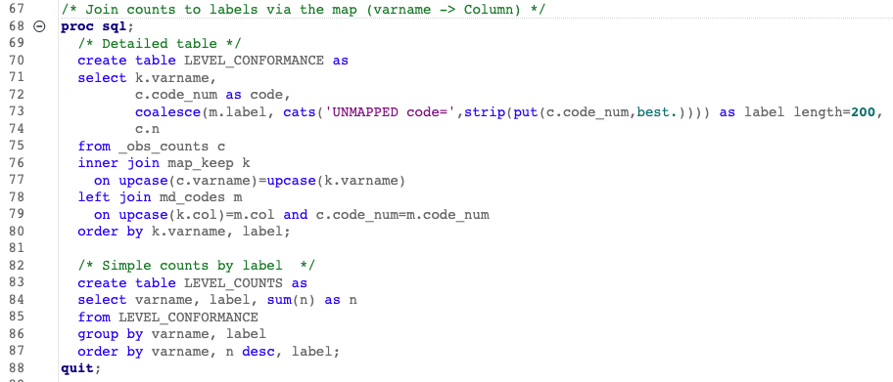
Figure 7. Code snippet of Metadata's Conformance Checks(Assign2/1_DataChecks/4_MetadataConformance.sas)
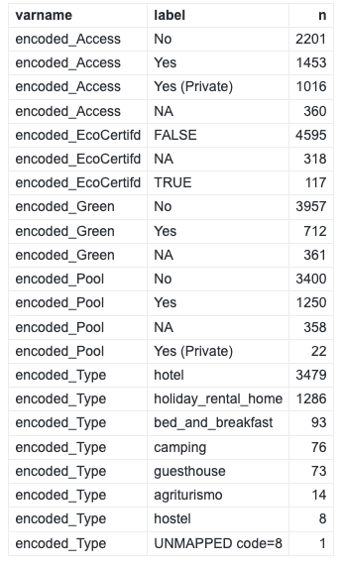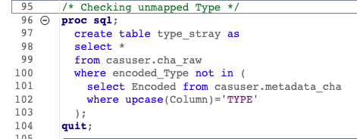
Figure 8. Results of the metadata conformance checks and code to check for unmapped type.
From the checks, there is one single unmapped code in encoded_Type where there is an 8 not listed in the metadata. Upon running further code, this belongs to the hotel named ‘Hotel Arizona’. This will be taken into consideration when performing analysis.

Variables Quick Look (Summary)

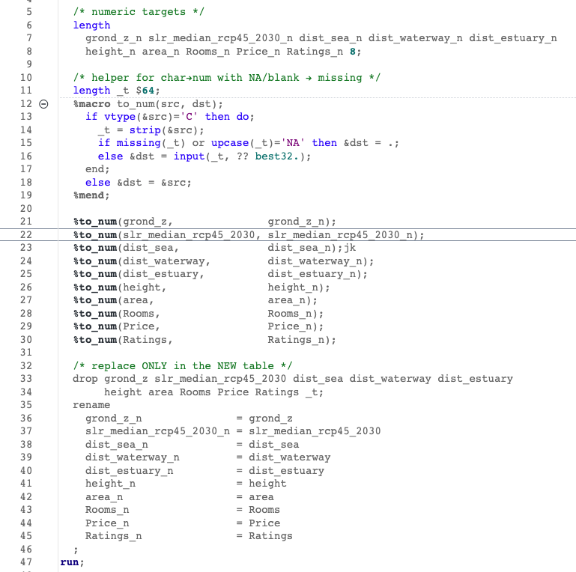
Figure 9. Code snippet to change categorical variables to numeric measures. (Assign2/1_DataChecks/5_VisualizationPreChecks)
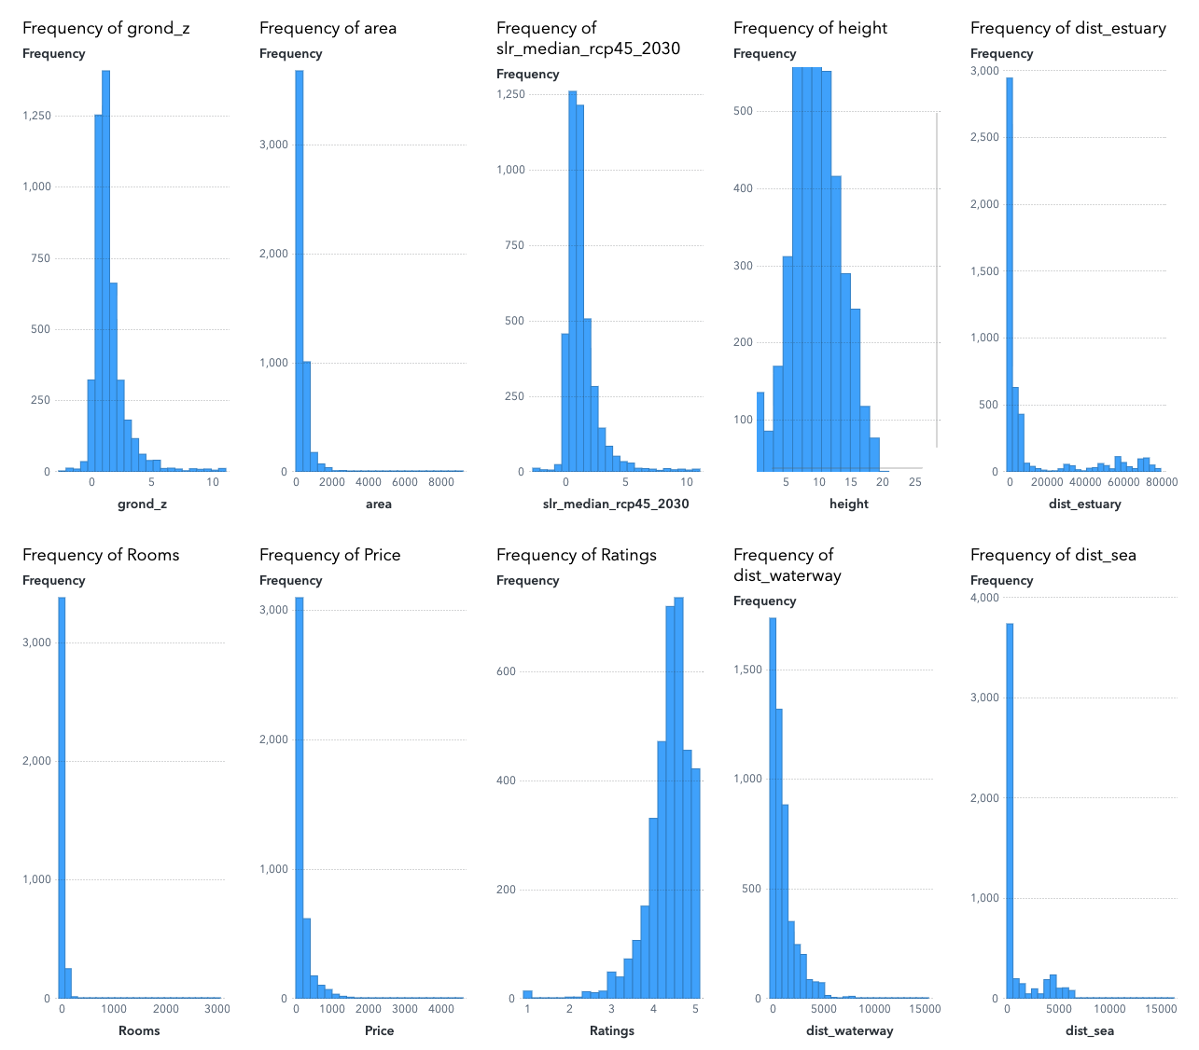
Figure 10. Histogram of variables (Assign2/Reports/1_QuickLook)
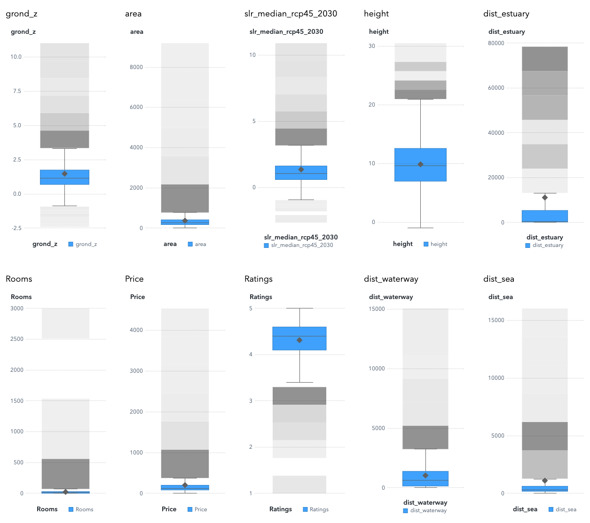
Figure 11. Box Plots of Variables(Assign2/Reports/1_QuickLook)

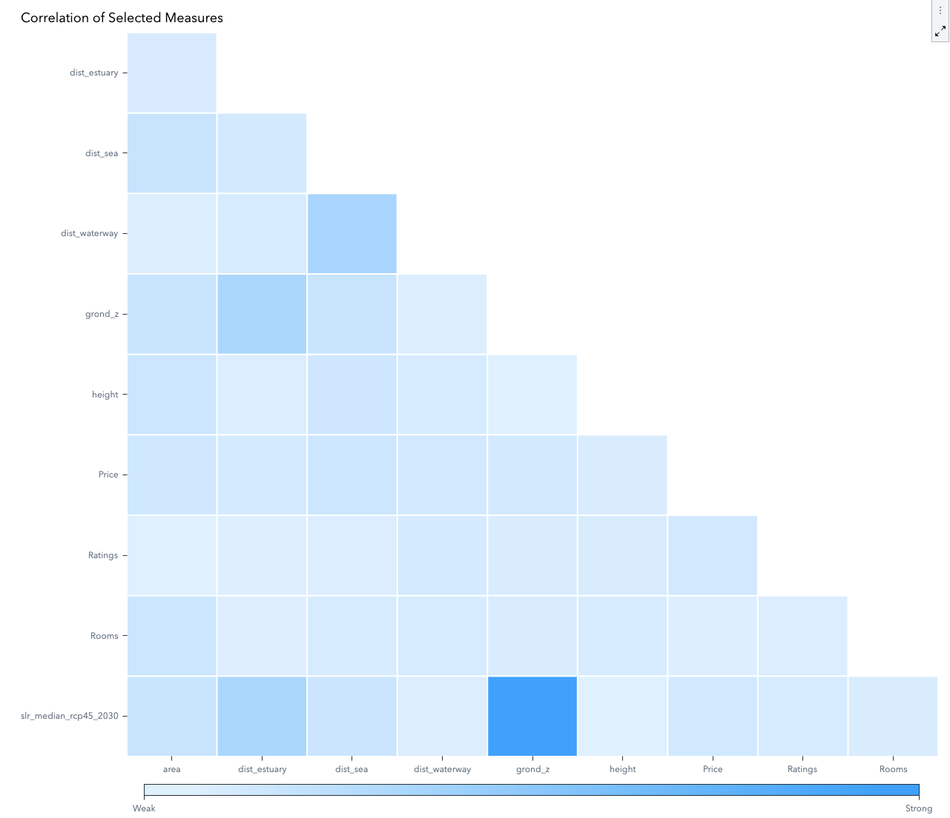
Figure 12. Correlation Matrix between Variables, results arrange in descending correlation (Assign2/Reports/1_QuickLook)
Distance measures are strongly right-skewed with many high-end outliers, indicating the need for standardisation and, if redundancy arises, a single coastal-proximity variable. The two elevation variables (grond_z and slr_median_rcp45_2030) are near-perfectly collinear (≈0.994), so only one should enter clustering to avoid double-counting. Physical-scale indicators show heavy right tails (Rooms, area) and mostly low values with a thin upper tail for height, again supporting standardisation and optional log-type sensitivity checks for Rooms/area. Market/quality variables diverge: Price is right-skewed; Ratings are bounded with a ceiling near 5, so both can be included but standardised. Apart from the elevation pair, correlations remain below the usual |r|=0.85 threshold, supporting a compact 6–7 variable set.

Data Preparation

Defusing Dummy Data: Height
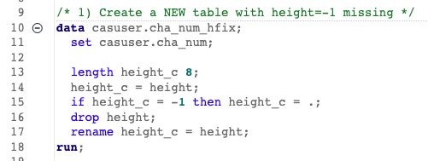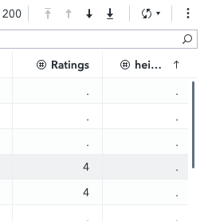
Figure 13. Code snippet of replacing -1 in height and its results(Assign2/2_DataPreparation/1_HeightFix)
From the pre-checks done, it was discovered that in the source data, there are 5 rows with height value of −1 which is a sentinel indicating “unknown,” not a physically meaningful measurement. Leaving −1 as numeric would create artificial low outliers, distort summary statistics and z-scores, and risk spurious separation in distance-based clustering. Replacing height = −1 with missing (NA) preserves the measurement scale, enables appropriate imputation alongside genuine missings, and prevents the placeholder from influencing cluster geometry.

Exposure Gap (Collinearity between 2 Variables)
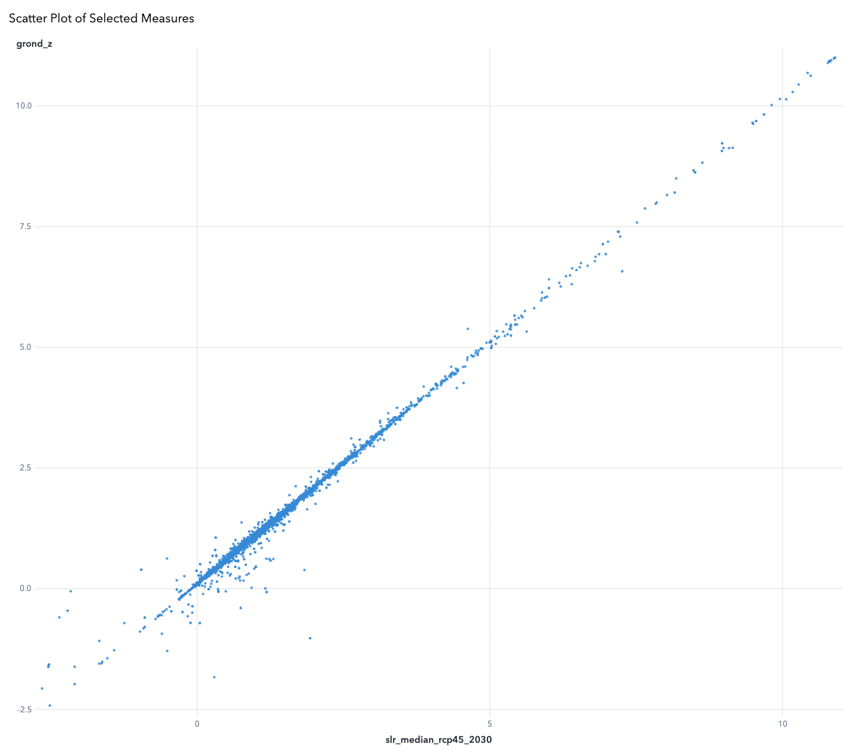
Figure 14. Scatter plot of grond_z vs slr_median_rcp45_2030
The scatter hugs the 45º line, confirming the two measures (grond_z and slr_median_rcp45_2030) are near-identical across properties.

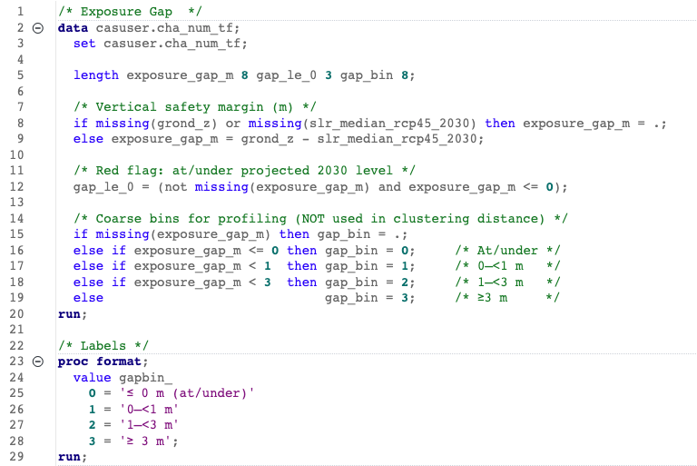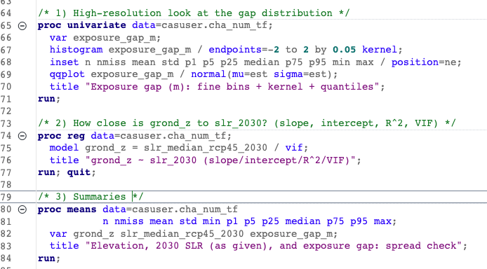
Figure 15. Code snippet of grond_z and slr_median_rcp45_2030 and its checks. (Assign2/2_DataPreparation/2_ExposureGap.sas)
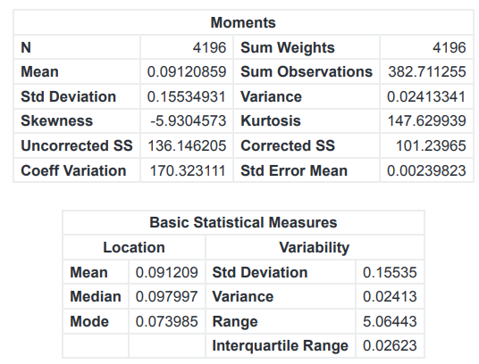
Figure 16. Result of checks
Regression shows grond_z ≈ slr_2030 (slope 0.995, intercept 0.10, R² 0.988). Consequently, the exposure gap (grond_z − slr_2030) is near zero for most properties (SD 0.16 m, IQR 0.026 m, ~16.6% missing) with only a few extremes, so as a standardized clustering driver, it would add little discrimination and risk amplifying noise. The decision is to use grond_z as the sole vertical driver; exclude slr_median_rcp45_2030.

Log Transformation
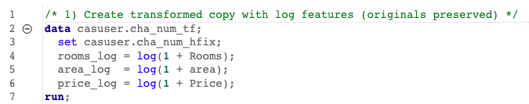
Figure 17. Code snippet of log transformation for Rooms, Area, and Price (Assign2/2_DataPreparation/3_LogTransformation.sas)

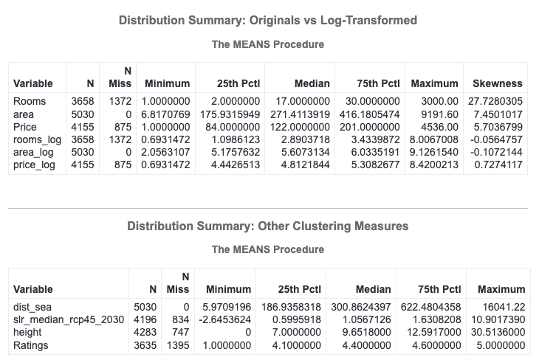
Figure 18. Result of log transformation
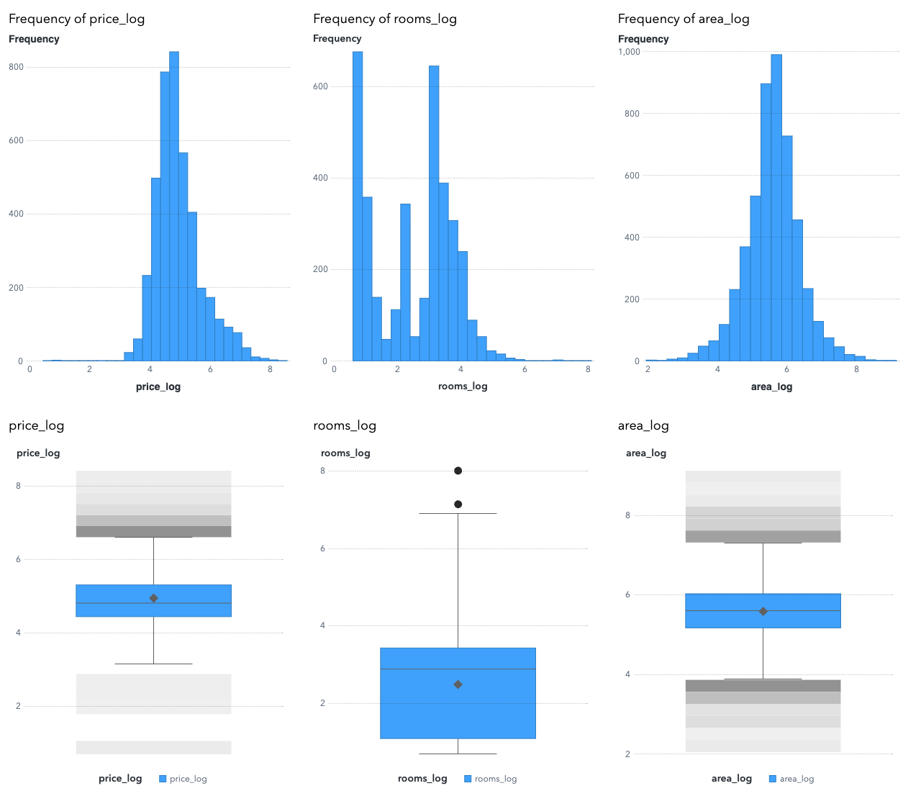
Figure 19. Histogram and box plot of log-transformed variables
Rooms, area, and Price were log transformed to tame their extreme right-skew and outliers so Euclidean distances aren’t dominated by a few very large properties/prices; the transform makes equal relative changes comparable. On the data it works as intended: skewness falls from 27.73 to −0.06 (Rooms), 7.45 to −0.11 (area), and 5.70 to 0.73 (Price), collapsing long right tails into near-symmetric shapes. The log transformed variables will feed the log features into clustering after standardizing them so each has comparable weight, and original units are kept for clear, human-readable profiling.

Z-Scoring
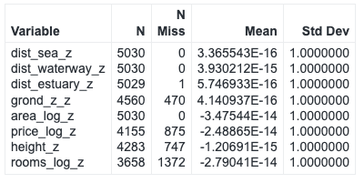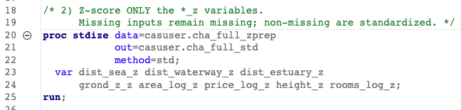
Figure 20. Code snippet and results of Z-scoring variables(Assign2/2_DataPreparation/4_ZScoring.sas)
The clustering work relies that is about to be done relies on Euclidean distance, which is highly scale-sensitive. Z-scoring puts every driver on a common scale(mean 0, SD 1), so they contribute comparably instead of letting the largest- variance variable dominate. This complements earlier log transforms. Medians on the distance z-scores are slightly negative, consistent with long right tails (a few properties very far from water pull the mean upward). Z-scores were created for all potential drivers so the data is cluster-ready, but only a selected subset will enter the distance metric.

Final Missingness Check
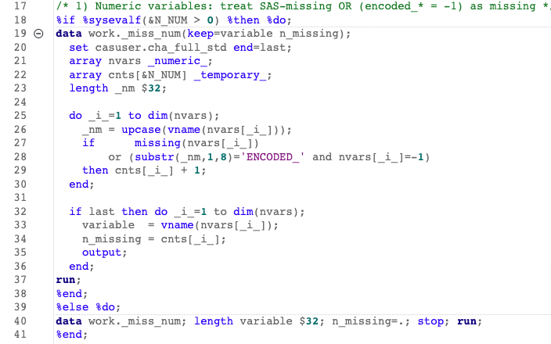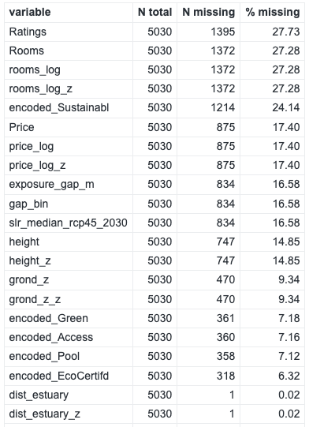
Figure 21. Code snippet of final missingness check and its results (Assign2/2_DataPreparation/5_MissingCheck.sas)
The first pre-check only counted true SAS missings (numeric . / blank char) and therefore understated gaps where placeholders exist (notably encoded_* = -1 and earlier NA-like tokens). A complete-case policy is adopted for clustering drivers: when a driver has < 20% missing, drivers with NA will be dropped. In the data this applies to price_log (17.4%), height (14.85%), and grond_z (9.34%), while dist_sea, dist_waterway, and area_log have 0% missing. This choice avoids injecting artificial structure into variables that drive Euclidean distance, and keeps the math transparent.

Duplicate rows
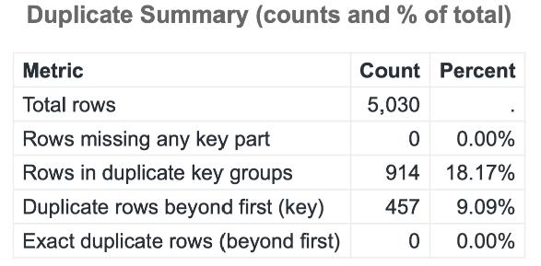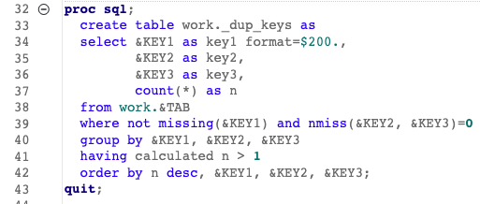
Figure 22. Duplicate check results and code snippets (Assign2/2_DataPreparation/6B_DuplicateChecks.sas)
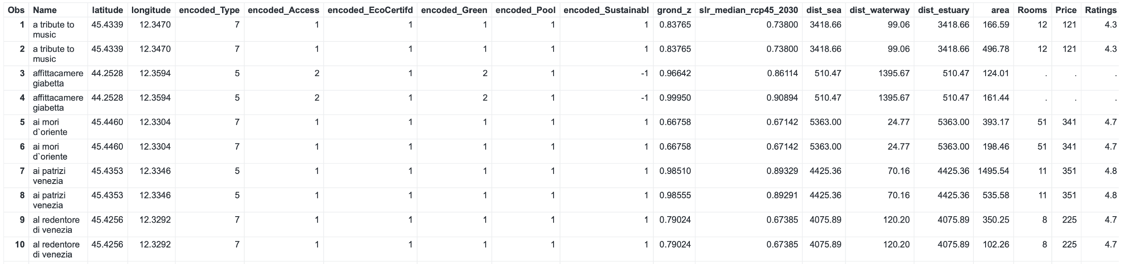
Figure 23. Sample duplicate rows where all the values are the same.
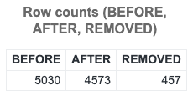
Figure 24. Duplicates removed sanity check (Assign2/2_DataPreparation/6B_RemovingDuplicates)
The dataset was audited again, this time for duplicate listings using the key Name + latitude + longitude and found 457 redundant rows (9.09% of 5,030). Each duplicate group was collapsed to a single record by ranking rows on completeness of core drivers/profilers. Post-checks confirmed that all unique keys were preserved and only extras were removed (5,030 → 4,573; removed = 457). This prevents double-weighting the same property and keeps the geographic/elevation/market signal clean for clustering.

Clustering Variables
*_z denotes variables that were z-scored during data preparation.
- dist_sea_z (distance to sea, z-scored): primary coastal attractiveness and surge-exposure proxy.
- dist_waterway_z (distance to river/canal, z-scored): fluvial/canal pathways and waterfront appeal distinct from the open sea. It is only modestly correlated with dist_sea_z, so it contributes new geometric signal.
- grond_z_z (ground elevation, z-scored): vertical safety. Prefer elevation in the distance metric and reserve derived exposure constructs (e.g., exposure_gap_m, gap_le_0) for post-hoc risk storytelling to avoid redundancy.
- area_log_z (log area, z-scored): asset scale and CAPEX proxy; log transformation stabilizes heavy right tails.
- price_log_z (log price, z-scored): market position/pricing power; log stabilizes skew and preserves rank order.
- height_z (building height, z-scored): structural verticality relevant to both risk mitigation and urban form.

Why not include dist_estuary in the distance?
Estuary proximity partly overlaps the elevation/proximity geometry and is less uniformly interpretable at network scale. Retaining it for profiling (not distance) keeps the clustering space parsimonious and avoids over-weighting coastal geometry.
Why not include rooms_log, Ratings, and encoded_*?
Their higher missingness and/or high dimensionality risk diluting the core geometry. It will be deliberately reserved for post-cluster validation and naming, which also strengthens criterion validity (clusters differ on variables not used to form them).

Complete Cases
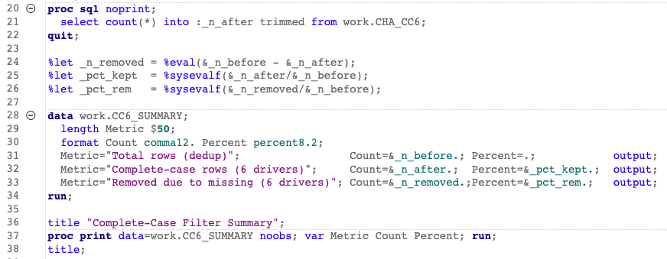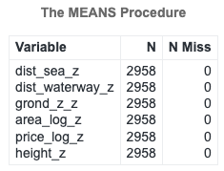
Figure 25. Code snippet for complete cases and its results (Assign2/2_DataPreparation/7_CompleteCases.sas)
Each of the six drivers had <20% missing individually, so removing rows with any missing among them is a simple, transparent way to (i) ensure identical samples across Ward, k-means, and GMM; (ii) avoid injecting imputation assumptions that can distort distances; and (iii) keep interpretability tight for the assignment.

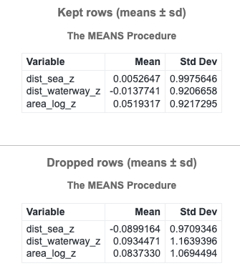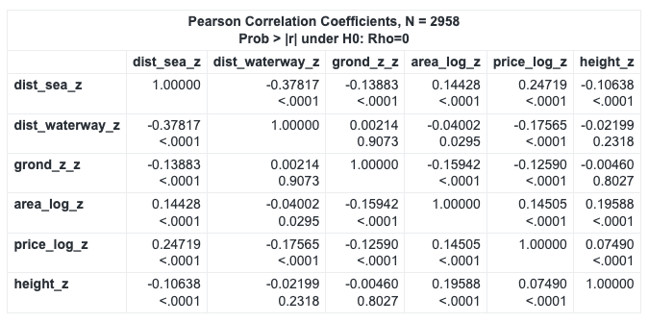
Figure 26. Result of checking shape on Complete Cases(Assign2/2_DataPreparation/8_CCCheck.sas)
After filtering to records with no missing values on the six drivers, all six drivers show 0 missing post-filter. The kept vs dropped comparison indicates only small mean shifts in coastal geometry (e.g., dist_sea_z kept ≈ 0.005 vs dropped ≈ –0.090; dist_waterway_z kept ≈ –0.014 vs dropped ≈ 0.093; area_log_z kept ≈ 0.052 vs dropped ≈ 0.084), suggesting the complete-case filter did not materially bias the spatial/size signal. Outliers are rare (|z|>4 counts: sea=7, waterway=12, elevation=44, area=5, price=8, height=3) and acceptable to keep. Pairwise correlations remain modest (largest magnitude ≈ –0.378 between sea and waterway), and regression VIFs for every driver sit ~1.0–1.26, confirming no multicollinearity concerns.

Data Analyses

Univariate Exploration of Clustering Drivers - Histograms
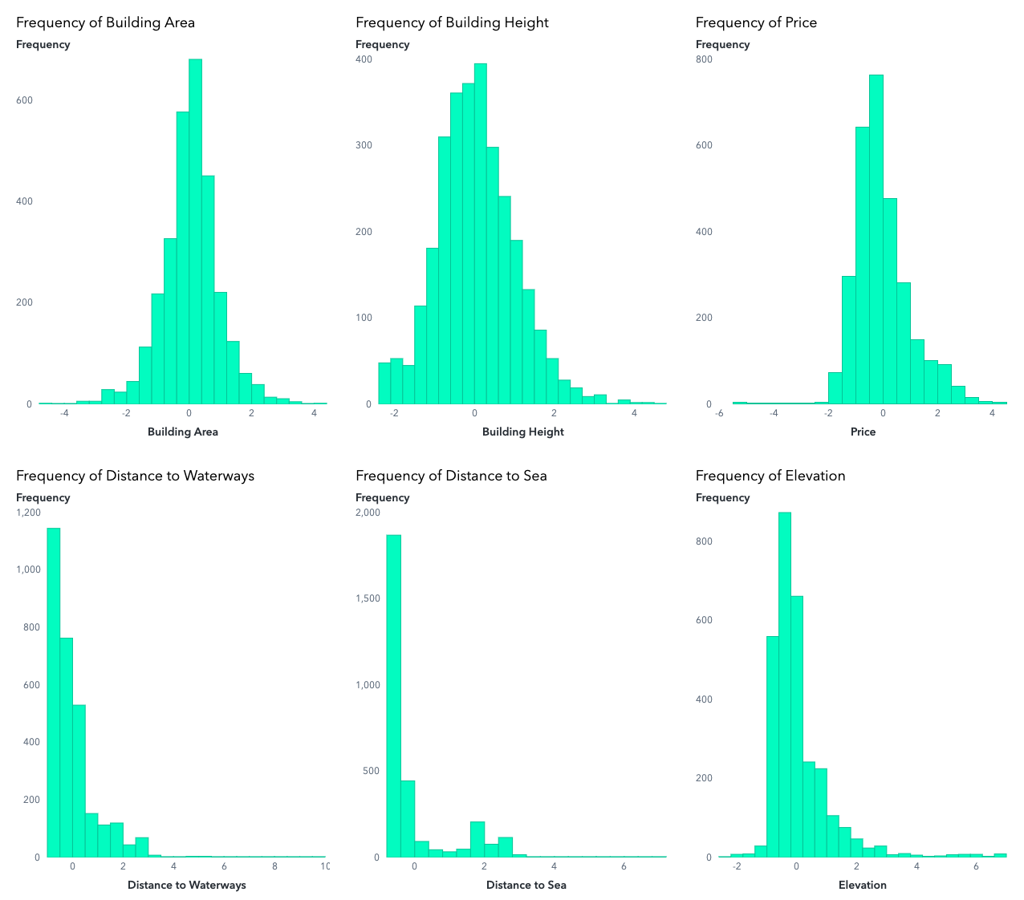
Figure 27. Histograms of Clustering Drivers
Across the six standardized drivers, Building Area, Building Height, and Price (area_log_z, height_z, price_log_z) are approximately normal and centered near zero. This is evidence that the log and z-score transformations worked and that these measures contribute comparably to Euclidean distances. In contrast, the spatial proximity variables – Distance to Sea, Distance to Waterways, and Elevation (dist_sea_z, dist_waterway_z, grond_z_z) are right-skewed, indicating most properties are close to coasts/canals and at low ground, with a smaller tail far inland or higher elevation. Together, these shapes justify the variable set: they capture two complementary dimensions which are location advantage (proximity/elevation) and asset scale & pricing (area/height/price), which is expected to drive the heterogeneity revealed by clustering.

Univariate Exploration of Clustering Drivers – Box Plots
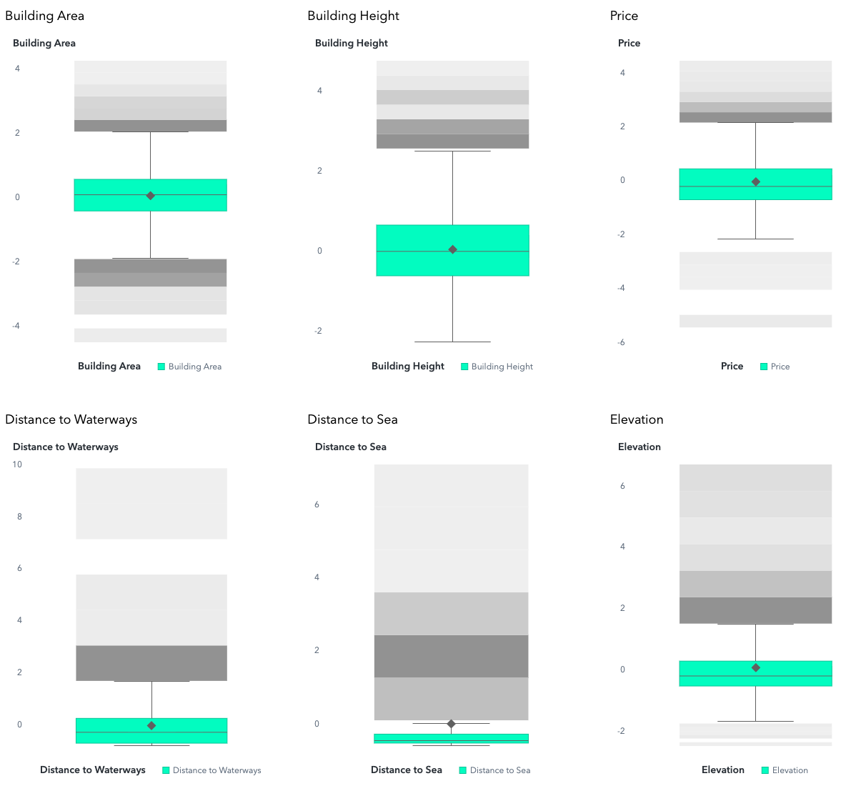
Figure 28. Box plots of clustering drivers
Overall, the boxplots confirm significant diversity in geographical and physical attributes, justifying the use of clustering to uncover natural groupings in the accommodation landscape. The right-skewed spatial variables (distance to sea/waterways and elevation) likely drive separation between coastal and inland clusters, while architectural and pricing variables (area, height, price) refine differentiation within those regions (e.g., premium vs. compact properties).

Tying in Univariate Analyses
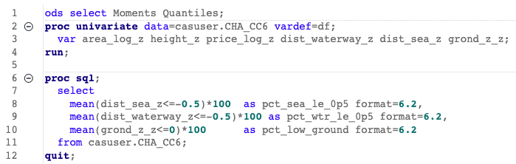
Figure 29. Code snippet for shape, symmetry and salience of univariate analyses
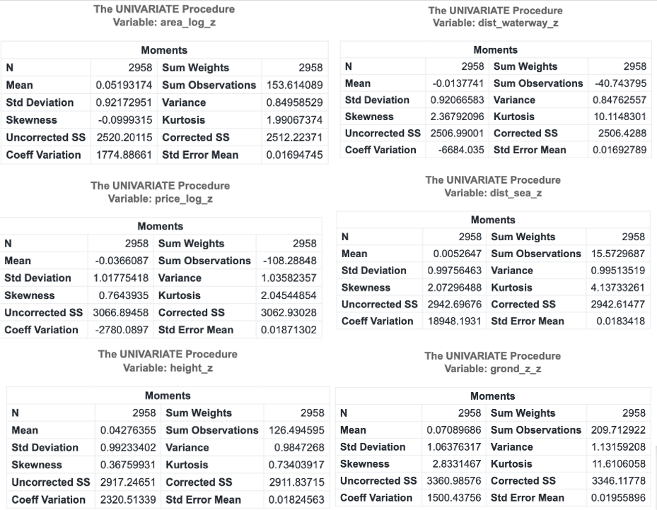
Figure 30. Result of findings to tie-in with Univariate Analyses
The shape and symmetry statistics corroborate the patterns seen in the histograms and boxplots. The structural variables: building area, height, and price are approximately symmetric and well-normalized after the log and z-score transformations. Skewness values near zero (−0.10, +0.37, +0.76 respectively) and moderate kurtosis (≈2.0) confirm these variables are roughly bell-shaped and evenly centered around the mean. This ensures that size, height, and price contribute proportionately to Euclidean distance in clustering, without distortion from extreme outliers.

In contrast, the spatial proximity variables: distance to waterways, distance to sea, and elevation exhibit strong positive skewness (≈2.1–2.8) and high kurtosis (>10). These long-right tails confirm that most accommodations are close to the coast or canals and at low elevation, while a smaller fraction sit far inland or higher above sea level. The salience analysis quantifies this: about 33% of listings are within 0.5 SD closer to the sea than average, 39% are similarly close to waterways, and 64% lie at or below mean elevation. Together, these results reinforce the visual evidence that the dataset is dominated by low-elevation, near-water properties, yet retains meaningful variation in both location and structure where variation that the upcoming clustering analyses will exploit to reveal distinct accommodation segments.

Bivariate Analysis
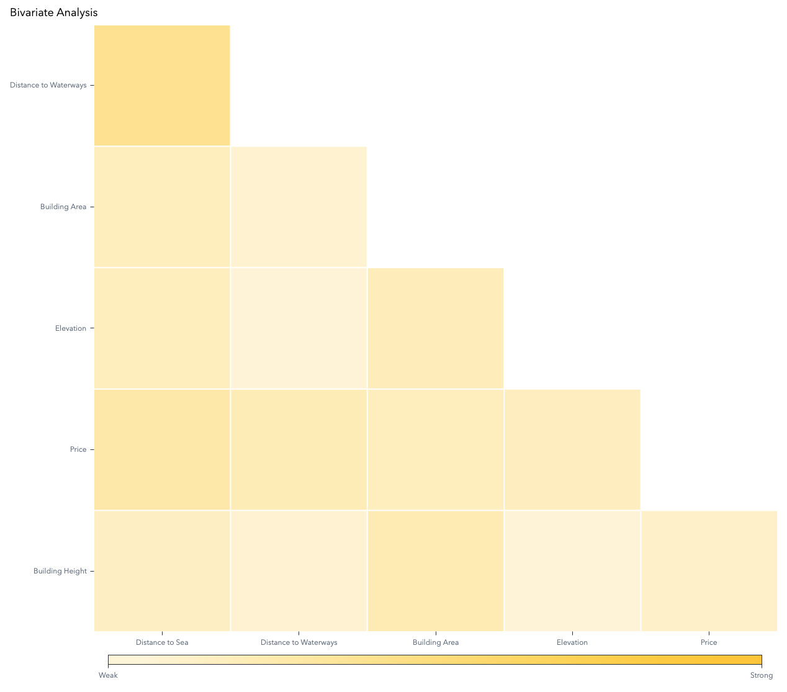
Figure 31. Correlation Matrix of Clustering Drivers
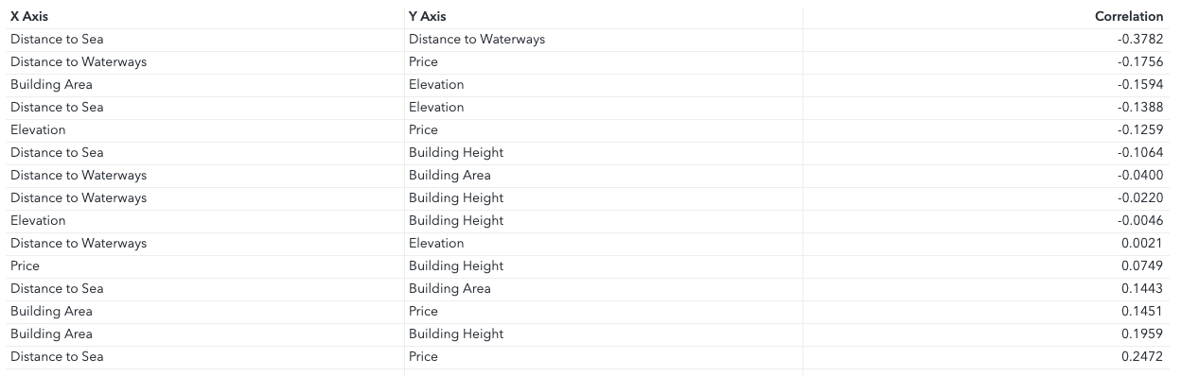
Figure 32. Correlation values between clustering drivers
In the bivariate matrix of the six standardized drivers (N=2,958; Pearson on z-scores), the strongest association is between Distance to Sea and Distance to Waterways (r = −0.3782), a moderate, negative relationship indicating that locations nearer the sea tend to be farther from waterways, and vice-versa. All other pairs are weak (|r|≲0.25), implying little risk of redundancy for clustering: Distance to Sea vs Price r≈+0.247 (slightly higher prices farther from the sea), Distance to Waterways vs Price r≈−0.176 (slightly higher prices nearer waterways), Area vs Height r≈+0.196 (larger sites are modestly taller), Elevation vs Area r≈−0.159, and Elevation vs Distance to Sea r≈−0.139. Remaining pairs are near zero (e.g., Elevation vs Height r≈−0.005). Overall, the matrix shows no high collinearity, supporting the use of all six drivers in clustering without additional variable pruning.

Hierarchical Clustering: Cluster Observation
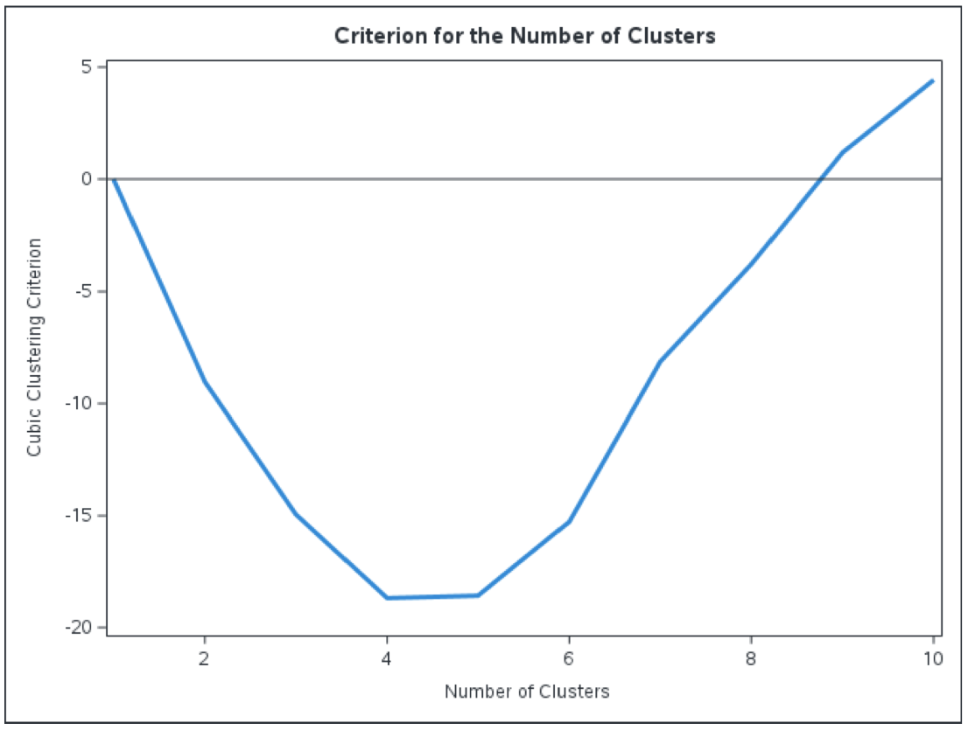
Figure 33. Cubic Clustering Criterion with the 6 Clustering Variables
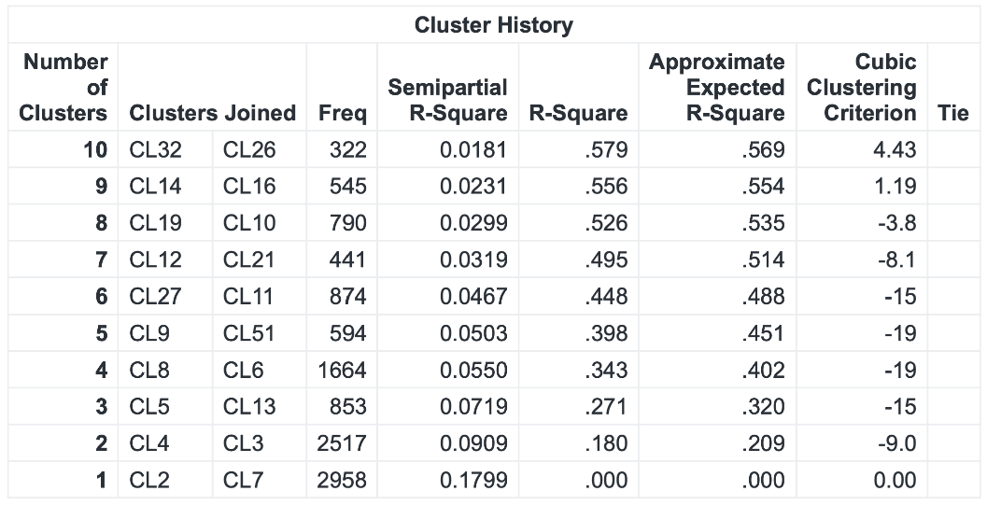
Figure 34. Results of Cluster Observations(Assign2/3_ExploreVisualize/1_HierarchicalClustering.ctk)
The CCC was evaluated on the observation-level Ward solution to choose a defensible cut. CCC is positive at 10 and 9 clusters(4.43 and 1.19), but turns negative from 8 downward, indicating weak global tendency toward a single “natural” k and motivating a pragmatic cut guided by business interpretability. For context, the root-mean-square inter-observation distance is 3.4189 in the standardized six-driver space. Looking at Figure 33, it was concluded to adopt k=5 to preserve salient structure while avoiding over-fragmentation.

Hierarchical Clustering: Dendrogram
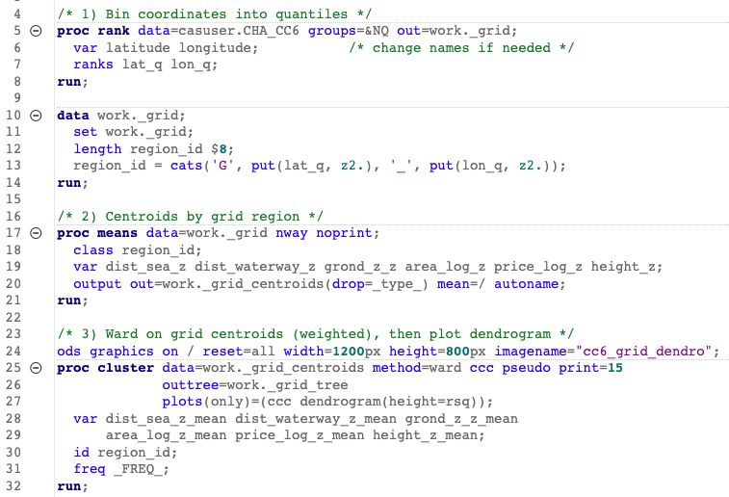
Figure 35. Code chunk to bin coordinates into quantiles for dendrogram (Assign2/3_ExploreVisualize/2A_Dendrogram.sas)
To make the hierarchical tree legible for 2958 observations, each property was assigned to a 10x10 latitude-longitude quantile grid and used the grid ID as the dendrogram leaf label. Each dendrogram leaf represents a cell’s median attribute values. This binning greatly reduced the number of leaf nodes and gave each leaf a spatial meaning (each has a defined geographic bounding box and a count of listings). Such an approach preserves clustering fidelity while yielding a more interpretable tree.

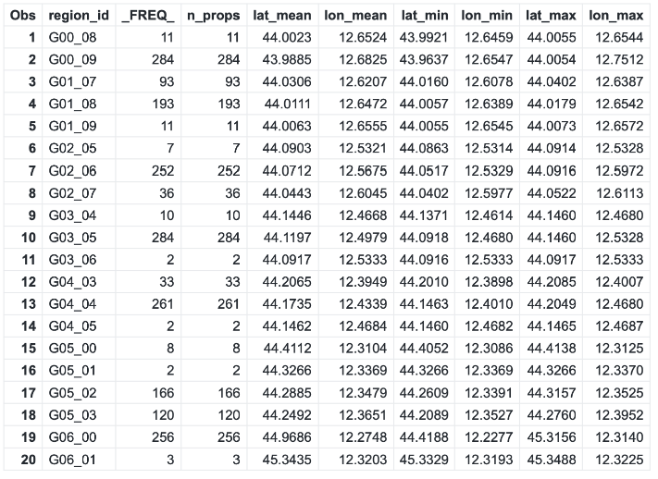
Figure 36. Result of the binning of latitude and longitude.
Each label has a centroid and bounding box plus a count of listings which makes the dendrogram leaf traceable to real geographic cell and shows how representative it is.

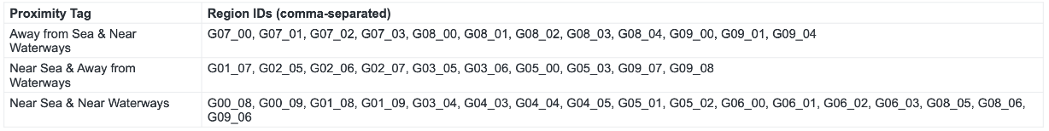
Figure 37. Label and Proximity Tag of Dendrogram
The binned leaves take on each region’s median-z distance to the sea and to waterways(negative = closer than average) and assigning one of three observed environmental regimes:
1. Near Sea & Near Waterways,
2. Near Sea & Away from Waterways, and
3. Away from Sea & Near Waterways

The grouped label table shows 17 regions in category, as percentages: 43.6% in category 1, 25.6% in category 2 and 30.8% in category 3. This distribution confirms that the study area is dominated by (1)coastal-waterway adjacency with substantial representation of (2)open-coast and (3)inland-waterway.

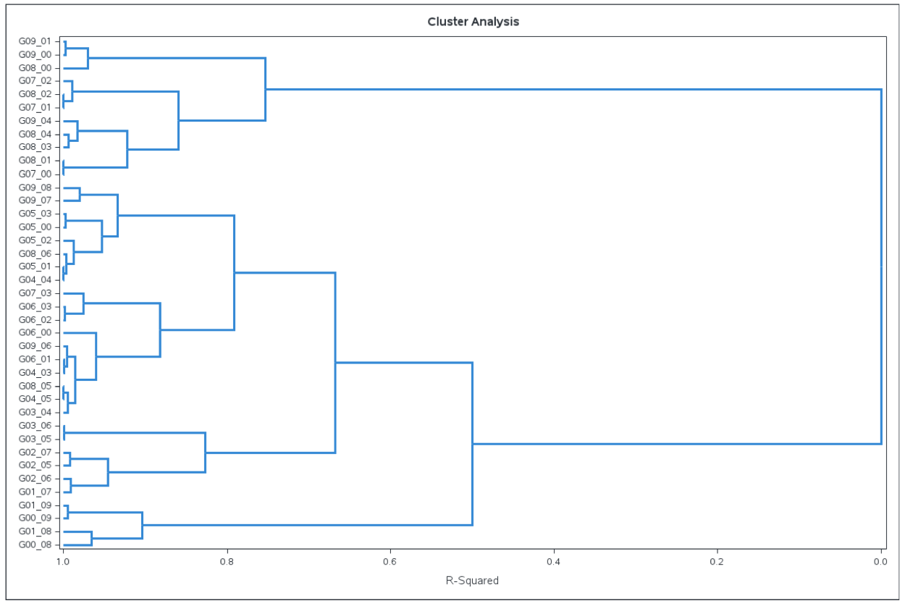
Figure 38. Dendrogram of the binned latitude and longitude vs the 6 cluster variables
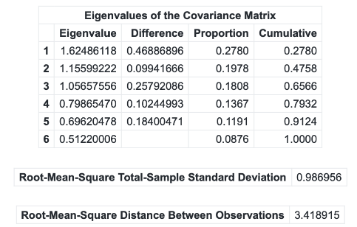
Figure 39. Result from the Cluster Observation Task
The dendrogram provides an interpretable story: the five-cluster cut partitions the grid leaves so that large blocks of Near Sea & Near Waterways regions sit together, reflecting shared exposure characteristics along the lagoonal/coastal interface, while Near Sea & Away from Waterways and Away from Sea & Near Waterways form their own coherent branches rather than being scattered, preserving meaningful environmental contrasts at k=5.

It is insightful to note how much variance in the data is captured by the first few dimensions of this hierarchical solution. A principal components analysis of the same Ward clustering run shows that the first two principal components explain about 47.6% of the total variance, and the first three explain 65.7%. This implies that much of the cluster separation can be visualized in two or three dimensions, consistent with the clear geographic story observed. In summary, the Ward dendrogram (with spatial binning) suggests a five-cluster structure where each cluster corresponds to a distinct coastal exposure archetype. This sets the stage for the next step of confirming and profiling these clusters with non-hierarchical methods.

K-Means Clustering
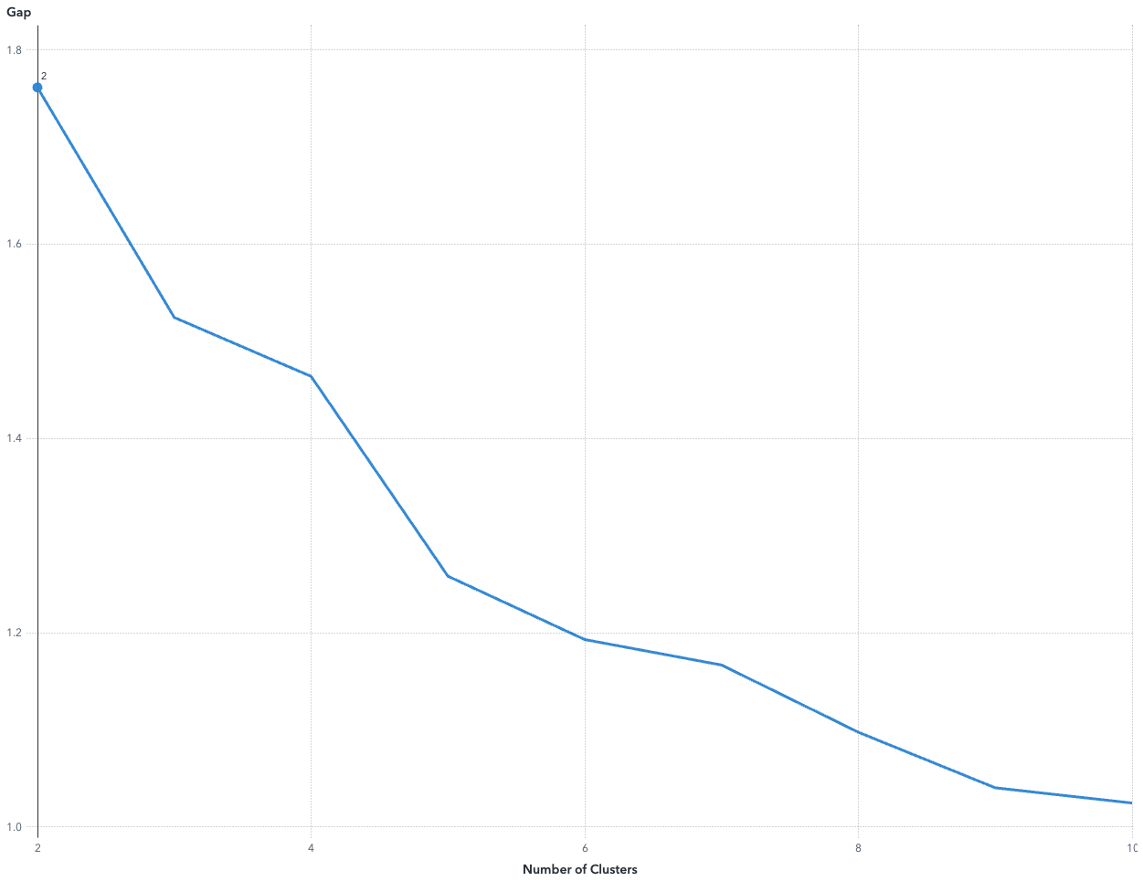
Figure 40. Aligned Box Criterion for K-Means Clustering
The aligned box criterion (a gap-style heuristic) peaks at k=2, indicating a strong global separation; however, per SAS guidance to prioritize interpretability, it is important to examine Ward’s hierarchy with CCC, pseudo-F, pseudo-t², and the dendrogram. Those diagnostics show a prominent merge change around the 5→4 cut, and the k=5 k-means delivers balanced and well-separated segments with clear business-meaningful profiles.

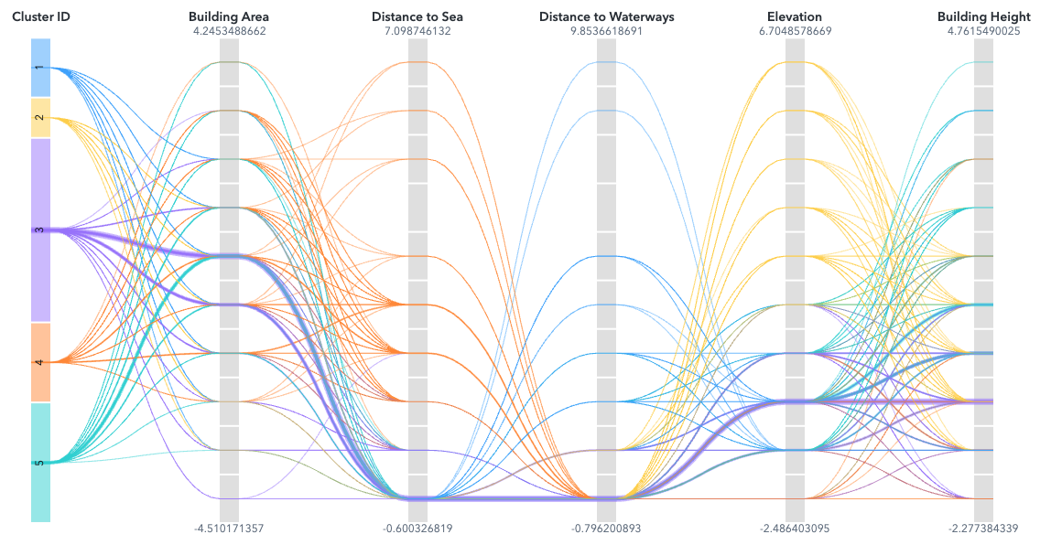
Figure 41. Parallel coordinates of K-means clustering.
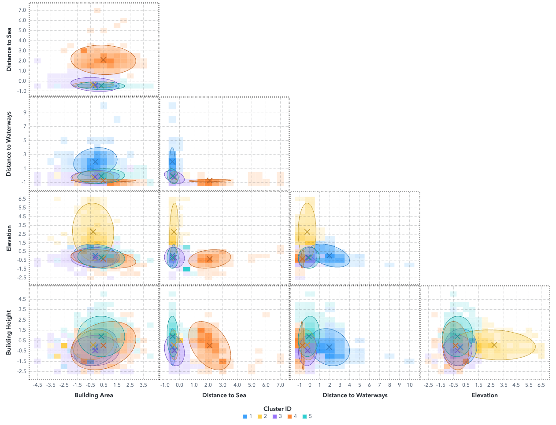
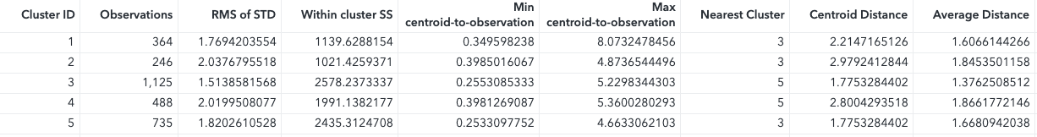
Figure 42. K-means clustering of the 6 clustering variables
All variables are z-scores; hence, negative values indicate closer/smaller/shorter/cheaper than the sample mean, positive values are opposite.

Cluster 1: Near-sea, away from rivers, budget low-rise (N=364).
Cluster 1 is driven by Sea = −0.48 and Waterways = +1.96 (closest to sea, far from waterways), plus Price = −0.45 and Height = −0.14 (value-priced, low-rise). Area is slightly below average (−0.14); Elevation near zero (+0.05). Compactness is reasonable (average distance to centroid 1.61) with a few far points (max distance ~8.07).

Cluster 2: High-ground coastal, small, value (N=246).
Cluster 2 follows the standout Elevation = +2.75 alongside Sea = −0.39 and Waterways = −0.28 (coastal despite high ground). Structure and price are smaller/value (Area = −0.31, Price = −0.38, Height ≈ +0.09). This is one of the looser clusters (avg distance 1.85).

Cluster 3: Waterfront budget low-rise (mass segment) (N=1,125).
Cluster 3 follows Sea = −0.35 and Waterways = −0.22 (close to both) and the lowest Price = −0.50 with Height = −0.45 (budget, low-rise). Area slightly below average (−0.16); Elevation slightly below (−0.17). It is the tightest cluster (avg distance 1.38), and its nearest centroid is Cluster 5 (distance ≈ 1.78), consistent with the scatter-matrix ellipses.

Cluster 4: Canal-front inland premium, larger footprint (N=488).
Cluster 4 for Sea = +2.10 (farthest from sea) and Waterways = −0.74 (very close to rivers/canals), combined with Area = +0.47 and Price = +0.64 (larger, premium). Height is near zero (+0.01), Elevation below average (−0.33). This group is among the looser ones (avg distance 1.87); its closest neighbor is Cluster 5 (centroid separation ≈ 2.80).

Cluster 5: Beach-near premium high-rise (N=735).
Cluster 5 for Sea = −0.47 (near sea) and the tallest Height = +0.90 with Price = +0.54 and Area = +0.31 (premium coastal towers). Waterways proximity is mild (−0.11), Elevation slightly below (−0.18). Compactness is solid (avg distance 1.67); nearest centroid is Cluster 3 (~1.78), indicating a premium vs budget continuum within near-water stock.

The five segments are balanced and cover the full supply spectrum: C1 to C5 percentages are 12.3%, 8.3%, 38.0%, 16.5%, and 24.9%, respectively. Compactness is acceptable across groups: the average distance from observations to their cluster centroid ranges from 1.376 (C3, tightest) to 1.866 (C4, loosest), with C1=1.607, C2=1.845, and C5=1.669. The smallest centroid-to-centroid separation occurs between C3 and C5 (1.775), indicating a smooth budget to premium coastal continuum rather than a hard break; the largest separation is C2 vs C3 (2.979), showing that the high-ground coastal value niche is most distinct from the waterfront budget mass segment.

Gaussian Mixture Model
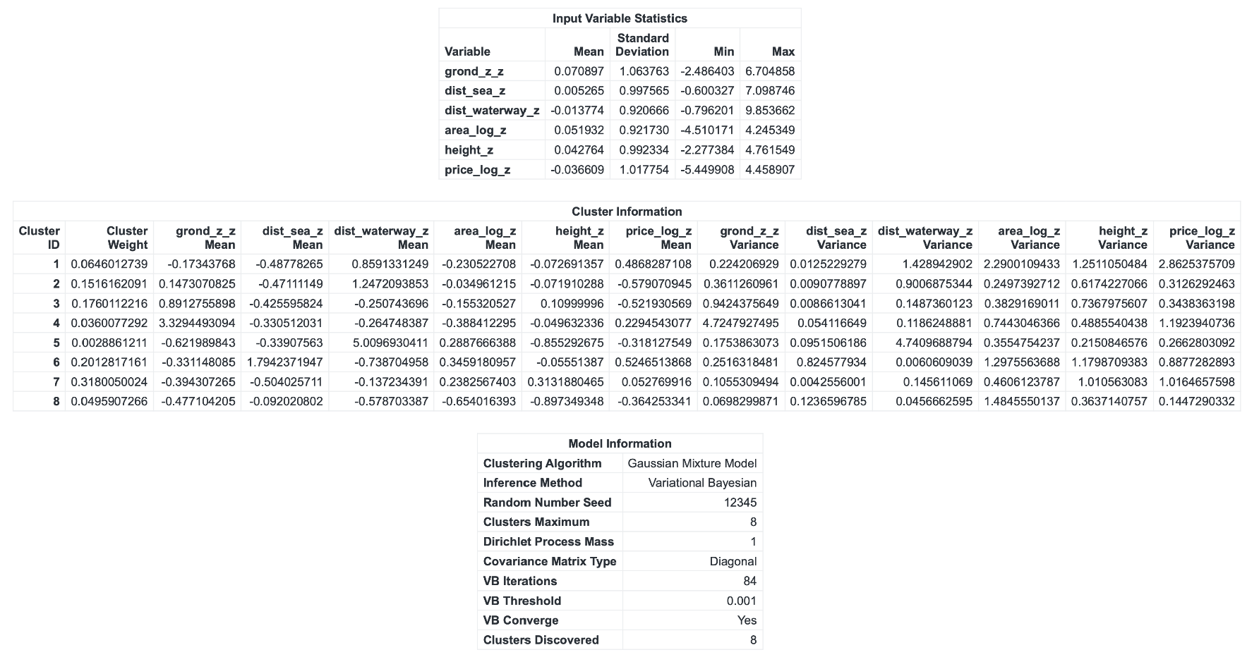
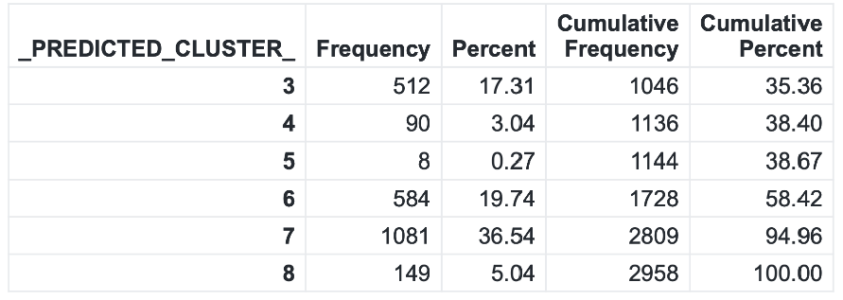
Figure 43. Output of GMM (Assign2/3_ExploreVisualize/3_GMM.sas)
As a final step, a Gaussian Mixture Model (GMM) was fitted to the data to further validate the segmentation. The GMM is a model-based clustering approach that provides soft assignments (each listing has a probability of belonging to each cluster) and can automatically discover an appropriate number of clusters based on data complexity. GMM converged on an 8-cluster solution. Notably, these 8 clusters turned out to be largely refinements or subdivisions of the five k-means segments rather than entirely new groupings – a reassuring sign that the underlying structure is consistent.

- C7 (36.54%): nearer the sea (dist_sea_z = −0.504), slightly closer to waterways (dist_waterway_z = −0.137), larger area (area_log_z = 0.238), taller (height_z = 0.313), above-average price (price_log_z = 0.313). This is a sizeable, near-sea, mid-rise, modest-premium segment.
- C6 (19.74%): far from sea (dist_sea_z = 1.794), near waterways (dist_waterway_z = −0.739), larger (area_log_z = 0.346), but price about average/slightly below (price_log_z = −0.056). This looks like inland, canal-adjacent, larger-footprint stock without a strong price premium.
- C3 (17.31%): near sea (−0.426), slightly near waterways (−0.251), smaller area (−0.155), slightly taller (0.110), below-average price (−0.522): a coastal value segment.
- C2 (13.49%): near sea (−0.471), far from waterways (1.247), roughly neutral size and height (−0.035, −0.072), below-average price (−0.579): another coastal value segment.
- Smaller clusters:
C1 (4.56%) near sea (−0.488), far from waterways (0.859), smaller (−0.231), price premium (0.487), a boutique near-sea premium niche. C4 (3.04%) very high elevation (grond_z_z = 3.329), near sea/waterway (−0.331/−0.265), small, slight premium (0.229). C8 (5.04%) near waterways (−0.579), small & short, discount (−0.364). C5 (0.27%) is tiny and atypical (e.g., dist_waterway_z = 5.010), suggesting an outlier pocket.

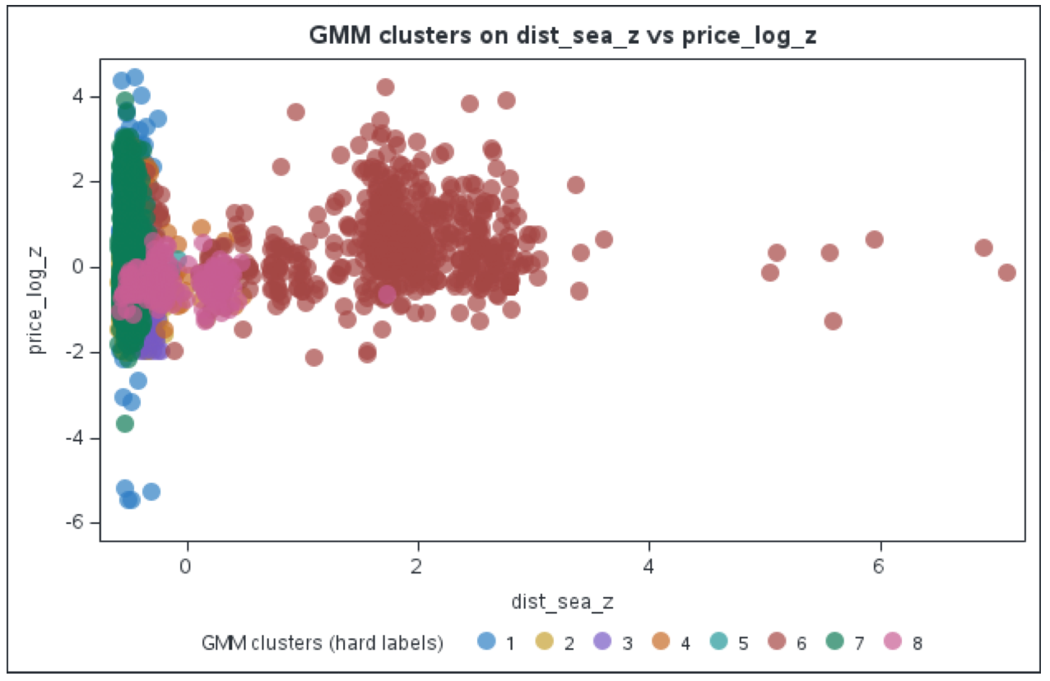
Figure 44. GMM Cluster Scatter Plot of Price (Log Transformed and Z-scored) vs Distance to Sea (Z-scored)
The cloud at near-sea (x < 0) contains both premium and discount listings, while the far-sea (x > 0) cloud is dominated by one cluster with prices around average. In other words, sea proximity alone does not guarantee a premium. The premium appears only when combined with certain form-factor attributes (area/height) and sometimes waterway proximity. This matches the cluster means: two near-sea clusters carry positive price deviations (C1: +0.487 SD; C7: +0.313 SD), while three other near-sea clusters are discount (C2: −0.579 SD; C3: −0.522 SD; C8: −0.364 SD).

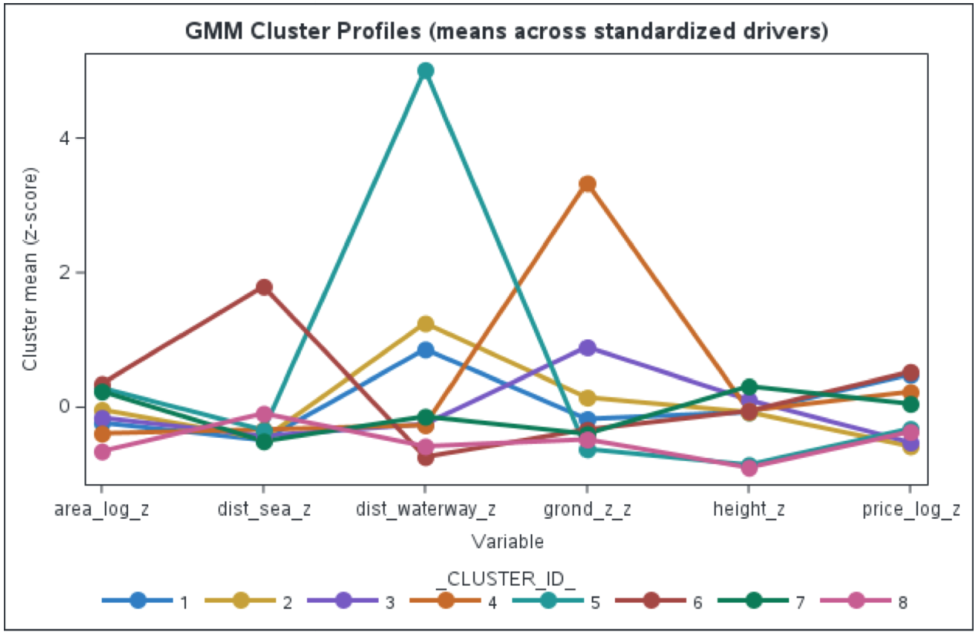
Figure 45. GMM Cluster Profiles
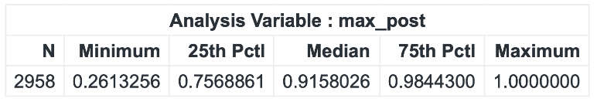
Figure 46. GMM Cluster (Means across standardized drivers)

Posterior max-probability is high: median = 0.9158, IQR 0.7569–0.9844 (25th–75th), max = 1.0000 which indicates confident assignments overall. The radar chart (cluster means across standardized drivers) shows that geography organizes the market and form-factor stratifies price within it: clusters split first by sea and waterway proximity and by elevation, then diverge on area/height and price. Overall, the radar confirms that sea proximity alone is insufficient; near-sea + size/height (sometimes aided by waterway adjacency) is what consistently lifts price, while near-sea without those attributes settles into value tiers.

Price by Segment: What Each Cluster Commands
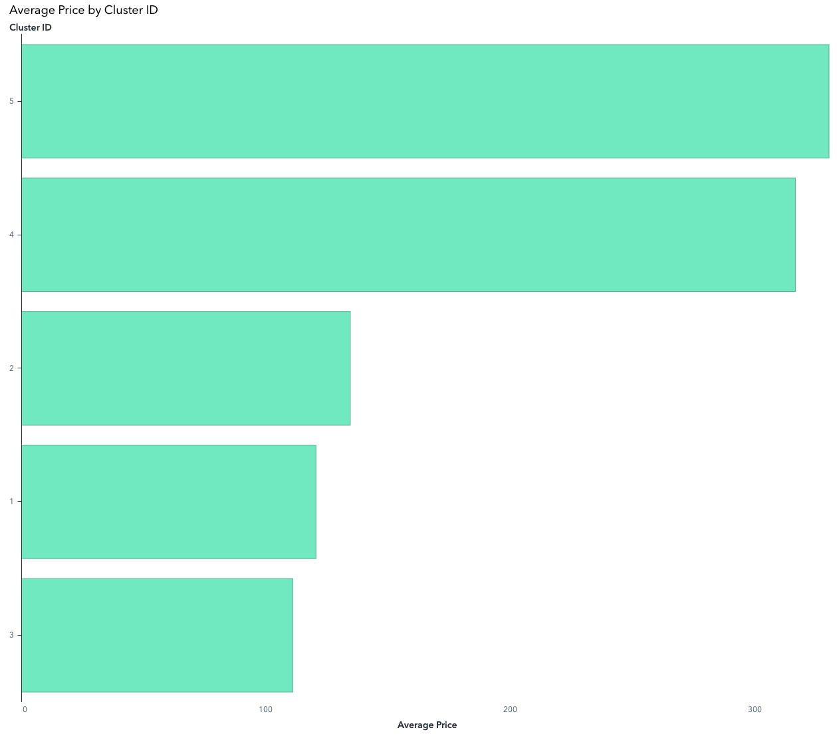
Figure 47. Cluster ID vs Average Prices
The bar chart is consistent with the clustering and working labels, showing compositional levers behind the monetisation. Cluster 5 (“beach-near premium high-rise”) and Cluster 4 (“canal-front inland premium, larger footprint”) monetise at the top end, while Clusters 1/3 (“budget low-rise” near sea/waterfront) anchor the lower tiers, and Cluster 2 (“high-ground coastal, small, value”) sits in between.

What Drives Price: Product Type & Access Features
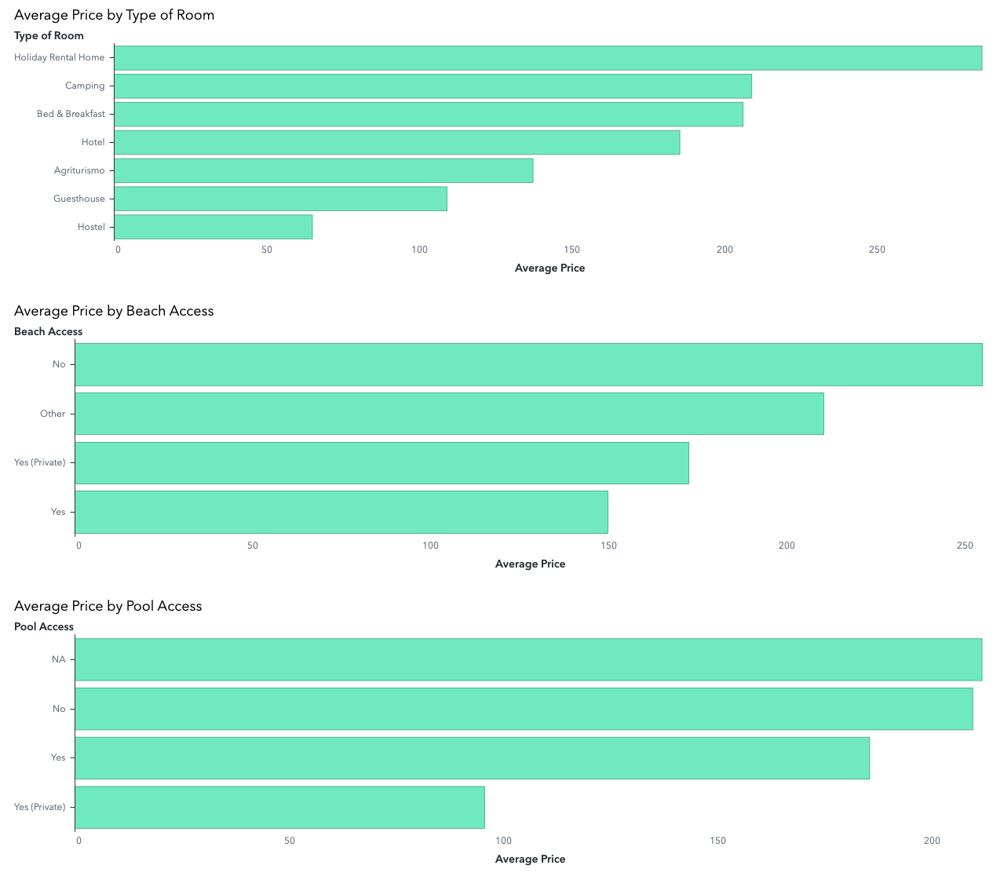
Figure 48. Average Price by Access Features

Type of Room:
Mean price is highest for Holiday Rental Homes (≈ 284), then Camping (≈ 209) and B&B (≈ 206), with Hotels lower (≈ 185). Hostels sit at the bottom (≈ 65). Sample sizes are large for Hotels (n=2,269) and Holiday Rental Homes (n=547) but very small for Agriturismo (n=4) and Hostel (n=6), so treat those two with caution. A one-way ANOVA across Types is significant (F≈9.91, p≈7.44×10⁻¹¹), indicating real differences in mean price between types.

Beach Access:
The mean is highest under “No” beach access (≈ 255), then “Other”/NA (≈ 210), “Yes (Private)” (≈ 172), and “Yes” (≈ 150). This tells us that direct beach access isn’t the only, or even primary price driver in this dataset; inland premium or canal-front locations (matching Cluster 4 label) likely command high prices without formal “beach access.” Differences are statistically significant (F≈42.66, p≈5.46×10⁻¹⁹).

Pool Access:
No pool and NA categories (≈ 209–212) average higher than shared pool (≈ 185), while private pool averages lowest (≈ 96) but with very small n=19, so that estimate is unstable. Differences are statistically significant but modest (F≈3.22, p≈0.040). Given the tiny private pool sample, it’s prudent not to over-interpret that category without more data.

Summary of Results
The hierarchical (Ward) analysis, k-means, and GMM collectively paint a coherent picture of the coastal hospitality market’s structure. The Ward dendrogram provided the initial evidence for around five clusters and ensured those clusters respect the major geographic groupings (sea vs waterway exposure). The k-means implementation at k=5 then gave us stable, interpretable clusters with clear profiles and good separation. Finally, the GMM without forcing k=5 independently discovered segments that align with the same five-group structure, only adding nuance by separating tiny niche clusters. It is reassuring that a completely different technique (model-based vs. distance-based clustering) reached a congruent segmentation, which speaks to the robustness of these patterns (Jain, 2010). All three approaches indicate that geography is the primary organiser of listings into clusters, and building characteristics plus price define sub-segments within those geographical groups. The fact that GMM assignment probabilities are high further implies that these clusters are not artifacts of the algorithm, but real groupings in the data. In summary, using multiple methods has strengthened our confidence in the solution: the Ward method revealed the presence of five meaningful clusters, k-means concretely defined those clusters, and GMM confirmed them (while highlighting finer subclusters). We can thus proceed knowing our segmentation is valid, data-driven, and grounded in both domain knowledge and statistical evidence, a crucial consideration for subsequent risk analysis and strategic planning (IPCC, 2020; NHESS, 2021).

Managerial Recommendations

- Wave and storm exposure: Hotels on unsheltered reaches face higher runup and overtopping. Add long-term 99th-percentile significant wave height and/or extreme wave climate. Upon research, this might be readily available from the Copernicus Marine Mediterranean wave products (Copernicus Marine Service, 2021).

- Land subsidence: Relative SLR at the property is elevation change minus sea-level change. Northern Adriatic coasts (Veneto/Po Delta) are well known for subsidence; add vertical land motion from the European Ground Motion Service (EGMS) to quantify mm/yr sinking at or near each asset, then roll it into relative SLR rates. This has become straightforward since EGMS went operational. (Copernicus, n.d.)

- Shoreline change & beach width: Distance to water misses whether the shoreline is advancing or retreating. Add a shoreline change rate (m/yr) and beach width (peak season). Something like EU datasets derived from EUROSION (European Environment Agency, 2024) and the newer CoasTER database that integrates erosion indicators on shoreline baseline; they’re European-scale and defensibly curated. Even a coarse sign (erosion vs accretion) improves separability.

- Accessibility (time, not distance): Replace or complement straight-line distances with travel time to the nearest beach access point, transit stop, town center, and nearest intercity rail station, computed on the road/walk network. These time-based variables are much more predictive for pricing and clustering than Euclidean distances.

- Replace the duplicative “estuary distance” with a geomorphic class: dist_estuary ≈ dist_sea for three-quarters of rows, switch to a coastal-setting categorical (open beach / lagoon or canalized back-beach / river mouth / hard-defended). It’s a single, interpretable splitter that captures different hazard pathways (overtopping vs backflow) and avoids double-counting distance.

- Compact, cluster-friendly: Clustering that reflects destination attractiveness without leaving the supply-side frame benefits from simple, reproducible proxies. Replace some straight-line distances with network travel times (e.g., to the nearest beach access point and intercity rail); add a small set of amenity densities (counts of restaurants, pharmacies, ATMs, marinas within 500–1,000 m from OSM). These measures are compact, auditable, and improve separation between “high-rise premium” and “waterfront budget” segments that happen to lie equally close to the sea.

7. References
Cortez-Ordonez, A., Vazquez, P.-P., & Sanches-Espigares, J. A. (2024). Features that influence bike sharing demand. Heliyon, Volume 10, Issue 18.
Heaney, A., Carrion, D., Burkart, K., Lesk, C., & Jack, D. (2019). Climate Change and Physical Activity: Estimated Impacts of Ambient Temperatures on Bikeshare Usage in New York City. Environ Health Perspect, doi: 10.1289/EHP4039.
Wang, H., & Noland, R. (2021). Bikeshare and subway ridership changes during the COVID-19 pandemic in New York City. Transp Policy, doi: 10.1016/j.
Yang, S., Brakewood, C., Nicolas, V., & Sion, J. (2019). Bikeshare Users on a Budget? Trip Chaining Analysis of Bikeshare User Groups in Chicago. Sagepub, DOI: 10.1177/0361198.
Eren, E., & Emre Uz, V. (2020). A review on bike-sharing: The factors aﬀecting bike-sharing demand. Sustainable Cities and Society.
IPCC. (2020). The concept of risk in the IPCC Sixth Assessment Report: a summary of crossWorking Group discussions. IPCC.
EGU. (2021). European Geosciences Union. Retrieved from Sea-level rise in Venice: historic and future trends: https://nhess.copernicus.org/articles/21/2643/2021/nhess-21-2643-2021.html
NHESS. (2021). Extreme floods of Venice: characteristics, dynamics, past and future evolution (review article). Retrieved from Natural Hazards and Earth System Sciences: https://nhess.copernicus.org/articles/21/2705/2021/
Carbognin, L., Teatini, P., & Tosi, L. (2009). WIT Transactions on Ecology and the Environment. Retrieved from https://www.witpress.com/Secure/elibrary/papers/RAV09/RAV09012FU1.pdf
Copernicus Marine Service. (2021). Mediterranean Sea Significant Wave Height extreme from Observations Reprocessing. Retrieved from https://marine.copernicus.eu/access-data/ocean-monitoring-indicators/mediterranean-sea-significant-wave-height-extreme
Copernicus. (n.d.). European Ground Motion Service. Retrieved from European Ground Motion Service: https://land.copernicus.eu/en/products/european-ground-motion-service
European Environment Agency. (14 February, 2024). Eurosion - Coastal Erosion and Defence. Retrieved from https://www.eea.europa.eu/en/datahub/datahubitem-view/ba6d7fe6-c79f-48c7-b738-f78260730538
Jain, A. (2010). Data clustering: 50 years beyond K-means. Pattern Recognition Letters, 651–666.

